Contents
Dave Sushames – Week 4 Individual Log 1
Experience 1
Reflection 1
Action 1
Dave Sushames – Week 10 Individual Log 2
Experience 2
Reflection 2
Action 2
Appendices 3
Appendix X(a) Dave Sushames Week 4 Individual Logbook Evidence 3
Logbook content notes 4
Appendix X(b) Dave Sushames Week 10 Individual Logbook Evidence 6
Logbook content notes 7

Dave Sushames – Week 4 Individual Log
This discussion references the content found in Appendix X(a) Dave Sushames Week 4 Individual Logbook Evidence

Experience
In week 4, I took charge of the Risk Assessment, Mitigation, and Contingency tables for the proposal, as well as the Gantt chart. Taking inspiration from Matt’s documentation layout, I started writing my logs in a similar format, with the exact hours of when work took place. At this point, we were looking for a way of working collaboratively on the same files, so I showed the team how to use Git.

Reflection
I did not work enough hours this week. With only 17 hours 15 minutes, there was a lot more time I could have spent on different parts of the proposal. When I did the maths, 450 hours over 17 weeks was at least 26.5 hours per week. My running total was only 40 hours, which was behind where it should have been. As I was only doing 17:45 hours by week 4, it wasn’t enough. I feel that if I had put more hours into the proposal, our team would have gotten a better grade for it.

Action
After this week, I committed to doing more hours per week. Each week, I worked out how many hours I needed using the formula [(450 - Running total) / weeks left], and aimed to do at least that many hours in the coming week. From this point onwards, my weekly hours increased, but not every week met the new target. Recalculating each week let me always know how far behind I was, and incorporated any excess or short hours I worked.

Dave Sushames – Week 10 Individual Log
This discussion references the content found in Appendix X(b) Dave Sushames Week 10 Individual Logbook Evidence

Experience
In week 10, we had an advisor meeting with Clement to discuss the weekly logs that Sam and I had not turned in. We came up with a few options for Olivia to present Dr Dax with, in the hopes that we could still turn them in. We did our mid-project presentation to Geoff, which went well. I rebuilt the LLM model with parameters more suited to DFIR work, and made a version of the Foremost script so that it would use tools like pdfcrack and steghide to extract encrypted information, but when I messaged Bryce he said this should be a stretch goal, and just report on the direct Foremost output. I also figured out a method to stop the LLM output from adding ANSI characters on the end of each line, by calling Ollama’s API directly instead of using the ollama run CLI.

Reflection
Missing my week 8 log deadline was a wake up call. It had been written and audited with the team, but I forgot to upload it until after the dropbox had closed. Despite us coming up with some reasonable sounding alternatives, we were told that we couldn’t turn in the missed logs, and should reflect on them in the Self Management Review. I spent all of Thursday working on an assignment for my other class, so I feel the lower amount of hours this week is justifiable. Setting the model’s parameters was an important step, that honestly could have happened earlier.
Finding out that using pdfcrack and steghide wasn’t required until after I had already done the work was frustrating as I had essentially wasted several hours, and highlighted the importance of understanding the project requirements before spending time on it.
Matt had found another way of resolving the ANSI characters by using a –nowordwrap flag in the command, which also invalidated the hours I had spent with the API. This emphasized the importance of communication within the team when working on similar tasks.

Action
After this week, I committed to upload each weekly log as soon as auditing was finished, rather than waiting for Wednesday to upload. I also decided to check with the team or with Bryce before starting any work, to make sure that it was actually required and not a stretch goal, as well as telling the team exactly what I was working on to prevent duplicated work. I know I have another assignment coming up for my other class, so I will plan ahead to make sure it doesn’t affect my required capstone hours when it comes up.

What I would change
If I could go back to week 1 of the capstone project, I would have done more hours of work earlier on, as having only 40 hours by the end of week 4 was not good. If I had done 28 hours of work from week 1, then there would have been no trouble achieving 450 hours. Also, I would have encouraged the team to submit the hourly logs as soon as we audit them, so there’s no chance of missing deadlines, which happened a few times. Lastly, I would have established the project scope better, as I had thought we were using tools such as pdfcrack and steghide as part of the foremost reports.

Appendices

Appendix X(a) Dave Sushames Week 4 Individual Logbook Evidence

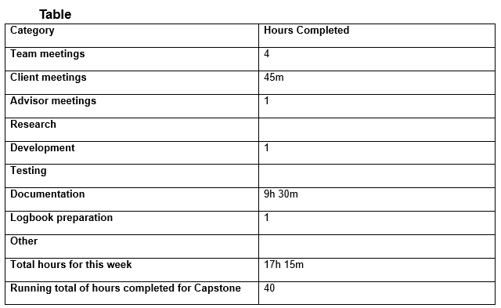

Logbook content notes
Team meetings:
Tuesday 10am – 11:30am. Attempted to have a meeting with Geoff, but he wasn’t able to make it, so we discussed our project proposal and who was covering which sections.
Friday 10:15am – 12:45pm. Group call where we went over the proposal and I made last minute edits.
Client meetings:
Wednesday 1:30pm-2:15pm. Recorded meeting with Geoff regarding requirements and deliverables.
Advisor meetings:
Thursday 12pm – 1pm. Meeting with Clement discussing what needs to be kept track of, and how the proposal is going. Sent him the current proposal draft for feedback.
Development:
Monday 2:30 – 3:30. 1 hr meeting to teach the team how to use git.
Documentation:
Monday 10am – 12pm, 1pm – 2:30pm. Worked on the risk assessment section of the proposal.
Wednesday 10am-1pm, 2:30pm – 4pm. Finished off the Risk mitigation and contingency plans, started on the Gantt chart.
Thursday 10:30am – 12pm. Finished the Gantt chart.

Appendix X(b) Dave Sushames Week 10 Individual Logbook Evidence

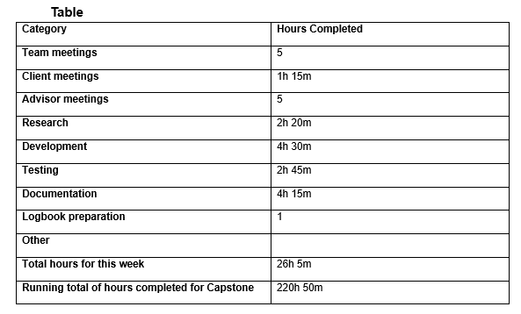

Logbook content notes
Team meetings:
Tuesday 9-2pm: Audited hourly logs, clarified upcoming meeting times. Arranged who would lead each presentation slide, made last minute refinements, did a practice run. Matt demo’d the foremost integration.
Client meetings:
Tuesday 2:30-3:45 Giving presentation to Geoff. Discussion about project progress,. Him giving us permission to do nmap/wireshark scanning on school network. Discussing AI’s limitations.
Advisor meetings:
Monday 8-10: Bryce gave advice for the presentation slides. Discussed inclusion of recent development in nMap. He showed how the network tunnelling through SSH could access his ollama server.
Monday 11-12: Meeting with Clement about presentation, as well as the project’s progress. Discussed mine and Sam’s missing weekly logs. Discussed how to document Olivia’s (PM) portion of the project.
Friday 9-11am: Meeting with Bryce about starting work on the poster and final client deliverables, self management review, version number updates, and what will happen with mine and Sam’s missing logs.
Research
See research log
Development
Spent some time figuring out how to set and adjust the gemma4:26b model’s parameters, especially setting the temperature to 0. Rebuilt the model as “gemma4-df” using the following parameters: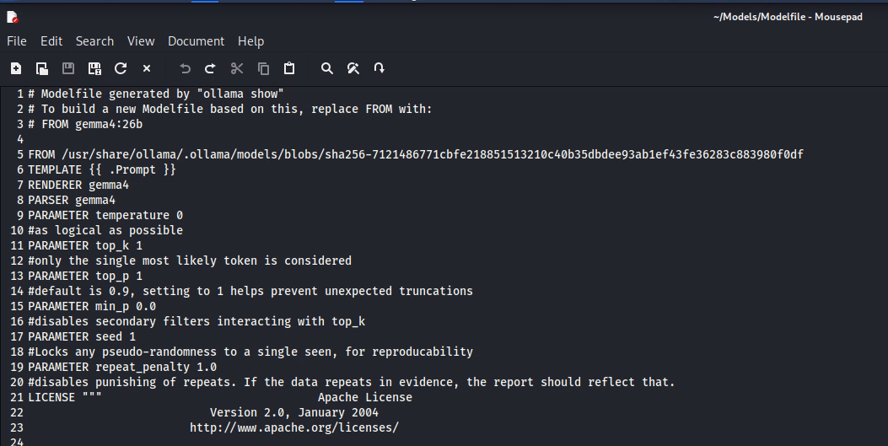
Encountered some issues with permissions, but solved it by adding a new group.
Ran the new model with Matt’s “Ninemost” foremost script, and continued work on a “Tenmost” script where it would attempt to use pdfcrack and steghide to extract encrypted information. In a communication with Bryce, he said this would be more of a stretch goal, so not needed at the moment.
Working on fixing the scripts to fix the end of line ANSI characters.
Testing
Running Nmap scans on my local machine, trying to get a handle on how it works, and how it is useful. 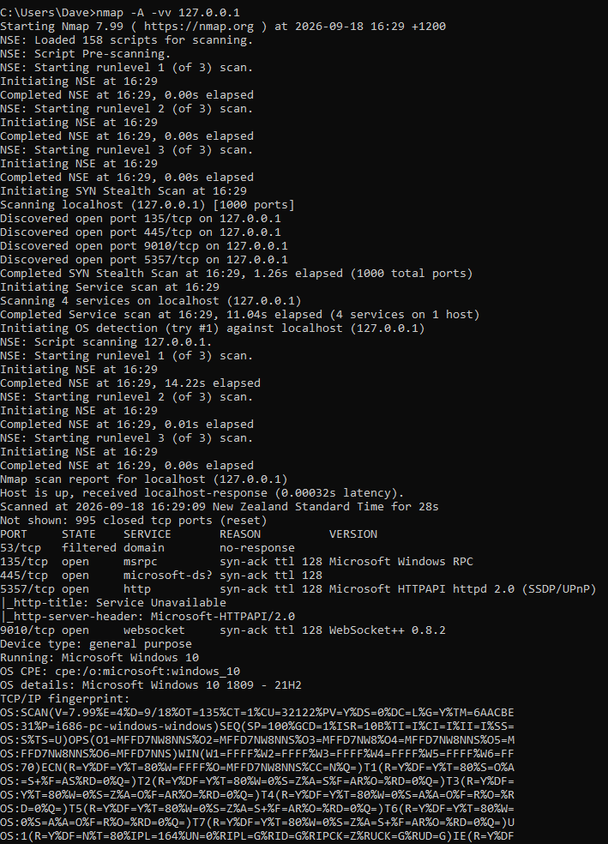
Nmap scans seem to take a very long time, depending on what you’re trying to get them to scan. 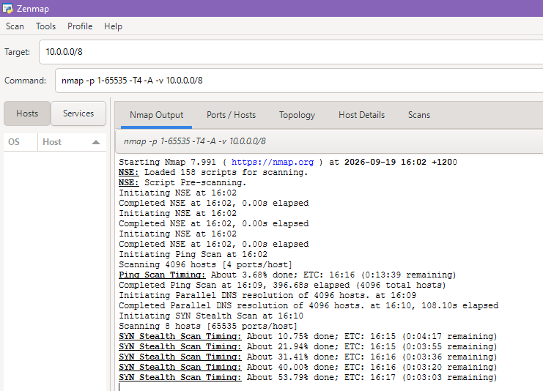
Managed to get an Nmap scan to export to a .txt file
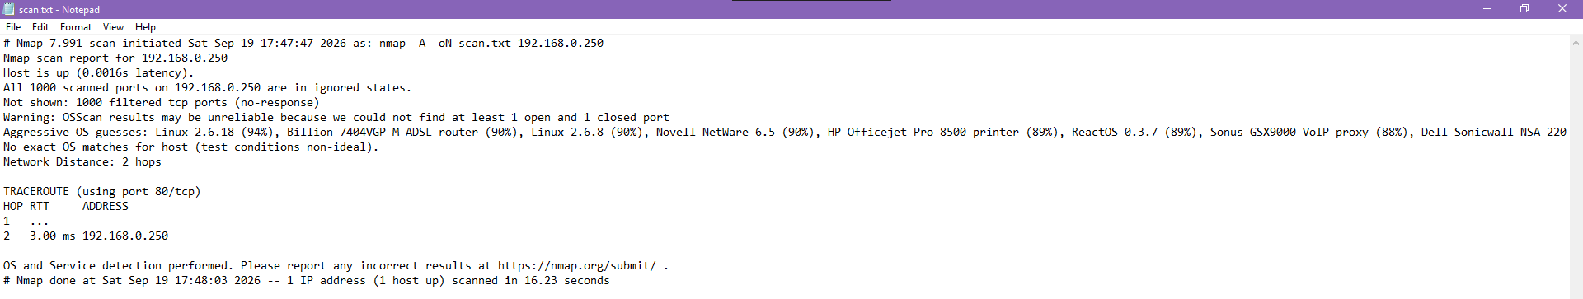
Documentation
Finalising the Mid-project presentation, doing a final pass on formatting.
Started work on the poster for the final panel. Deciding the sections that information would be laid out in.

